Table of Content

- Problem Statement
- Process Model
- Requirement Analysis
- Data Flow Diagram (DFD)
4.1 Level 0 DFD
4.2 Level 1 DFD
4.3 Level 2 DFD
4.3.1 Data Management
4.3.2 Session Manager
- Data Dictionary
5.1 User Login Details
5.2 Attendance Marking
5.3 Access Control Data
- Use Case Diagram
- Software Requirements Specification (SRS)
7.1 Functional Requirements
7.2 Non-Functional Requirements
7.3 Performance Requirements
7.4 Software System Attributes
7.5 Logical Database Requirements
7.6 Environment Characteristics
- Sequence Diagram
- Structure Chart
- Project Management
10.1 Timeline Chart
10.2 Function Point Calculation
10.3 Effort Estimation
10.4 Cost Estimation
10.5 Risk Analysis
10.6 Risk Mitigation
- Architecture Design
- Code Base & Test

Acknowledgement

I would like to express my sincere gratitude to my respected teacher for their invaluable guidance, constant support, and encouragement throughout the development of this project titled “Secure Attendance Management System”. Their insights and suggestions have played a crucial role in shaping this project and enhancing my understanding of software engineering concepts.
I am also thankful to the Department of Artificial Intelligence for providing the necessary resources, facilities, and a conducive environment that enabled me to successfully complete this project. The academic support and infrastructure provided by the institution have been instrumental in the completion of this work.
I would like to extend my appreciation to my friends and classmates for their continuous support, constructive feedback, and cooperation during various stages of the project. Their discussions and suggestions helped me overcome several challenges.
Finally, I would like to acknowledge my own efforts and dedication in completing this project, which has significantly improved my practical knowledge and understanding of system design, data flow modeling, and software development methodologies. This project has been a valuable learning experience, and I am grateful for the opportunity to work on it.

Problem Statement

In many educational and organizational environments, attendance management is still performed using manual or semi-digital systems that lack proper security, structure, and access control. These systems are prone to issues such as data inconsistency, unauthorized modifications, lack of accountability, and exposure of sensitive information.
A major limitation of existing systems is the absence of role-based access control, where all users (APIs) may have similar levels of access regardless of their responsibilities. This can lead to serious problems such as unauthorized data manipulation, inability to track changes, and difficulty in managing large datasets efficiently.
Furthermore, sensitive data such as student records and attendance logs are often stored in unencrypted formats, making them vulnerable to data breaches and misuse. There is also a lack of efficient querying and reporting mechanisms, which limits the ability to extract meaningful insights from the stored data.
To address these challenges, there is a need for a secure, structured, and role-based Attendance Management System that differentiates between administrative and regular user responsibilities.
In this system:
- The Admin is responsible for overall system control, including user management, modification of attendance records, and assignment of access permissions.
- The User (API) is provided restricted access, allowing them to view and query attendance data based on predefined permissions without altering the core database.
The system must ensure:
- Secure storage of data using encryption techniques
- Controlled access through role-based permissions
- Integrity and consistency of attendance records
- Efficient data retrieval and reporting
Thus, the objective is to design and implement a system that not only automates attendance management but also enforces security, accountability, and structured access control, overcoming the limitations of traditional approaches. The system must be able to run on a server with moderate cpu speed but slow disk read speeds. To ensure stability, such a system will only manage data transfer and access control, but not modification as thus can be achieved by loading the extracted data.

Process Model

The development of the Secure Attendance Management System follows an Iterative Process Model with structured phases similar to the Waterfall Model. This approach was chosen to combine the clarity of a sequential development process with the flexibility required to refine and improve system components during development.
Initially, the system requirements were analyzed to identify key functionalities such as secure authentication, role-based access control for Admin and User, and efficient attendance data management. Based on these requirements, a modular system design was developed, dividing the system into distinct components such as authentication, data management, encryption, and query processing. This structured design ensures separation of concerns and improves maintainability.
During implementation, each module was developed independently and integrated progressively. The iterative nature of the model allowed continuous refinement, particularly in critical areas such as data encryption, access control, and query handling. Testing was performed alongside development to verify correctness, security, and reliability, ensuring that errors could be identified and resolved early.
This process model is particularly suitable for the system because it provides a clear development structure while allowing incremental improvements. Since the system involves sensitive data and multiple user roles, the ability to iteratively refine security mechanisms and access controls is essential. At the same time, the structured phases help maintain proper documentation and organization throughout development.
Thus, the chosen process model ensures a balanced approach, supporting both systematic development and flexibility, leading to a secure, reliable, and well-organized Attendance Management System.

Requirement analysis

Data Flow Diagram

Data Flow Diagrams (DFDs) are a graphical representation used to illustrate the flow of data within a system. They help in visualizing how data is processed, stored, and transferred between different components such as processes, external entities, and data stores.
DFDs provide a clear understanding of system functionality by breaking down complex operations into simpler, structured representations. They are developed at different levels of abstraction, starting with a high-level overview (Level 0) and gradually expanding into more detailed representations (Level 1 and beyond).
In this system, DFDs are used to represent the interaction between users, administrative controls, and the underlying data management processes, ensuring clarity in system design and data handling.

Level-0 Data flow diagram
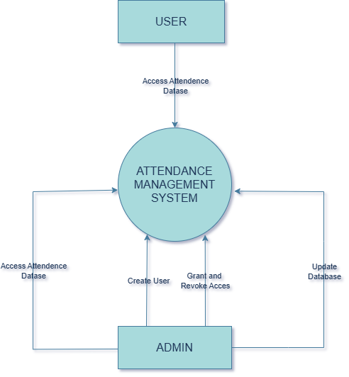

The Level 0 Data Flow Diagram, also known as the Context Diagram, represents the system as a single high-level process and illustrates its interaction with external entities. It provides an overall view of how data enters and leaves the system without showing internal processing details.
In this level, the entire Attendance Management System is treated as one unified process, while external entities such as the Admin and User interact with the system by providing inputs and receiving outputs. The diagram also highlights the major data flows between the system and external entities, along with connections to data stores where information is maintained.
The purpose of the Level 0 DFD is to give a clear and simplified understanding of the system’s boundaries, inputs, outputs, and its relationship with external actors, without exposing internal complexity. This serves as a foundation for further detailed representations in higher-level DFDs.

Level-1 Data flow diagram
The Level 1 Data Flow Diagram provides a more detailed representation of the system by decomposing the main process shown in the Level 0 DFD into multiple sub-processes. It illustrates how different functional modules interact with each other and with data stores to perform specific operations.

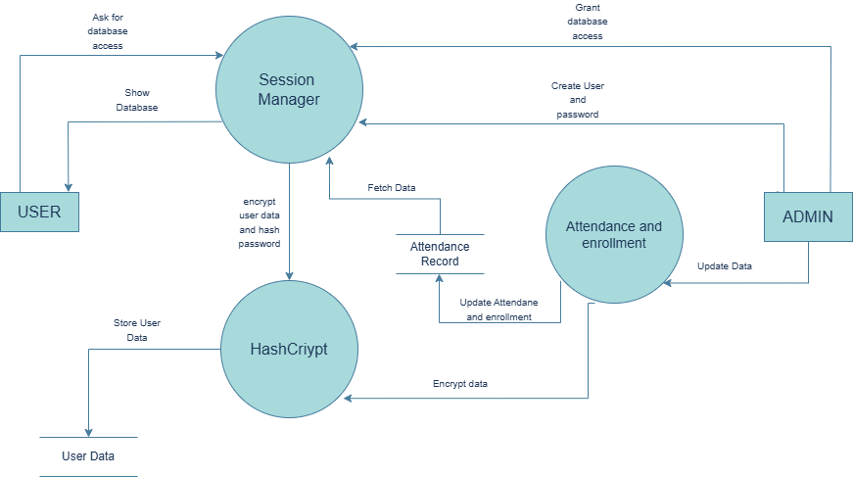

In this system, the Attendance Management System is divided into key processes such as Session Management, Authentication, Data Management, Query Processing, and Encryption. Each process is responsible for handling a specific aspect of the system’s functionality. The Session Manager controls the overall flow of operations, while the Authentication module verifies user credentials. The Data Management module handles attendance records, and the Query module processes user requests for retrieving data. The Encryption module ensures that sensitive data is securely handled.
The diagram also shows how these processes interact with data stores such as user credentials, access permissions, and attendance records. Data flows between processes and storage components are clearly represented, highlighting how information is processed, stored, and retrieved within the system.
The purpose of the Level 1 DFD is to provide a clearer understanding of the internal working of the system by breaking down the main process into manageable components, while still maintaining a high-level view without going into implementation details.

Level-2 Data flow diagram

  - Data Manager

The Level 2 Data Flow Diagram for the Data Management module provides a detailed view of how attendance data is processed within the system. This module is responsible for handling all operations related to attendance records, including insertion, modification, deletion, and retrieval of data.
The Data Management module receives input from the user (Admin/User) through the Session Manager in the form of requests such as adding a new record, updating existing data, deleting records, or fetching specific attendance information. Based on the type of request, the module directs the flow to the appropriate sub-process.
The module is decomposed into four main sub-processes: Add Record, Update Record, Delete Record, and Fetch Data. Each sub-process performs a specific operation on the attendance dataset. The Add Record process inserts new attendance entries, while the Update Record process modifies existing records. The Delete Record process removes unwanted or incorrect data, and the Fetch Data process retrieves records based on user queries.

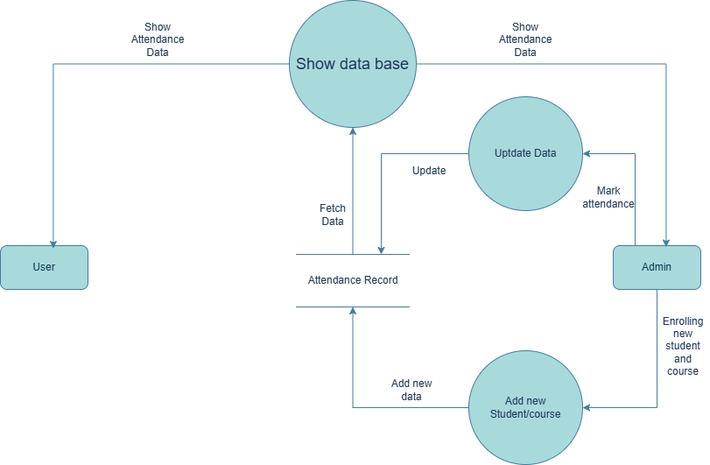

All these sub-processes interact with the Data Storage, where attendance data is stored in a structured and encrypted format. The Data Management module ensures that data is properly validated before performing any operation, maintaining data integrity and consistency.
This decomposition improves clarity by breaking down a complex process into simpler components, making it easier to understand, implement, and maintain. It also highlights how data flows between different internal processes and the storage system, ensuring efficient and controlled data handling.

  - Session Manager

The Level 2 Data Flow Diagram for the Session Manager module illustrates the internal workflow responsible for controlling system interaction and managing user sessions. The Session Manager acts as an intermediary between the user and the core system modules, directing requests and ensuring proper execution of operations.
The module begins by receiving input from the user in the form of login credentials or operation requests. It first initiates the Login Handling process, where user credentials are forwarded to the Authentication Module for verification. Upon successful authentication, the session is established, and the user is granted access to the system.
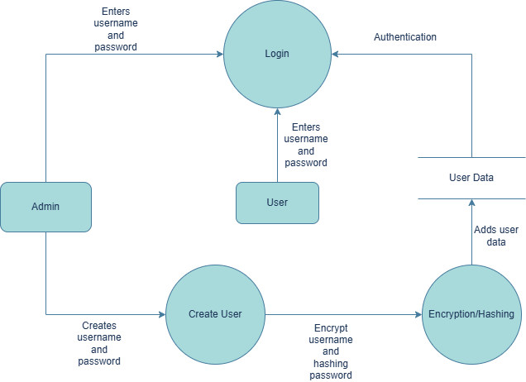

Once authenticated, the Session Manager processes user commands through the Request Processing sub-process. Based on the type of request, it directs the flow to appropriate modules such as Data Management for record operations or the Query Module for data retrieval.
The module also includes a Session Control process that maintains the state of the user session, ensuring that only authorized users can perform operations during an active session. Additionally, a Logout Process is responsible for terminating the session and revoking access when the user exits the system.
This decomposition highlights how the Session Manager coordinates system activities, controls access flow, and ensures secure and organized interaction between the user and various system component.

Data Dictionary

User login details:
User login details will be managed by the admin only, admin can create a user, grant and revoke permissions and also delete a user.

Name | Data Type | Size | Constraints | Description
User Name | String | Variable | Primary Key | Username defines the name user will access the database with
User Password | hex(64) | 64 | Not Null | Pass must contain letter, number and special characters and is required for api access

Attendance marking:
Name | Data Type | Size | Constraints | Description
Student id | Int(10) | 10 | Not Null | Student id will be the key to mark attendance for particular student.
Course id | CHAR(6) | 6 | Not Null | Course id is used to mark students attendance in that course.
Date | Date(DDMMYYYY) | 8 | Not Null | Date to marks attendance for that date.
Attendance(p/a/-) | Char | 1 | - | Attendance will take 1 length character for either p or a null value will make the attendance unmarked

Access control data:
Name | Data Type | Size | Constraints | Description
Student list | list[hex(64)] | Variable | - | Allowed Student ids
Course id | list[hex(64)] | Variable | - | Allowed Course ids
Date | list[hex(64)] | Variable | - | Allowed Date ids

Use case Diagram

A Use Case Diagram is a behavioral diagram that represents the interaction between external actors and the system. It illustrates the various functionalities provided by the system and shows how different users engage with these functionalities.
In the Secure Attendance Management System, the primary actors are the Admin and the User, each having distinct roles and permissions. The Admin has full control over the system, including managing users, modifying attendance records, and assigning access permissions. In contrast, the User interacts with the system in a restricted manner, primarily for viewing and querying attendance data.
The diagram identifies key use cases such as login, managing users, updating attendance, executing queries, and viewing records. It clearly distinguishes between administrative operations and user-level functionalities, ensuring a structured and secure interaction with the system.
The purpose of the Use Case Diagram is to provide a high-level understanding of system functionality from the user's perspective, highlighting how different actors utilize the system without detailing internal implementation.
The diagram helps in identifying system boundaries and ensures that all functional requirements are properly captured and represented.
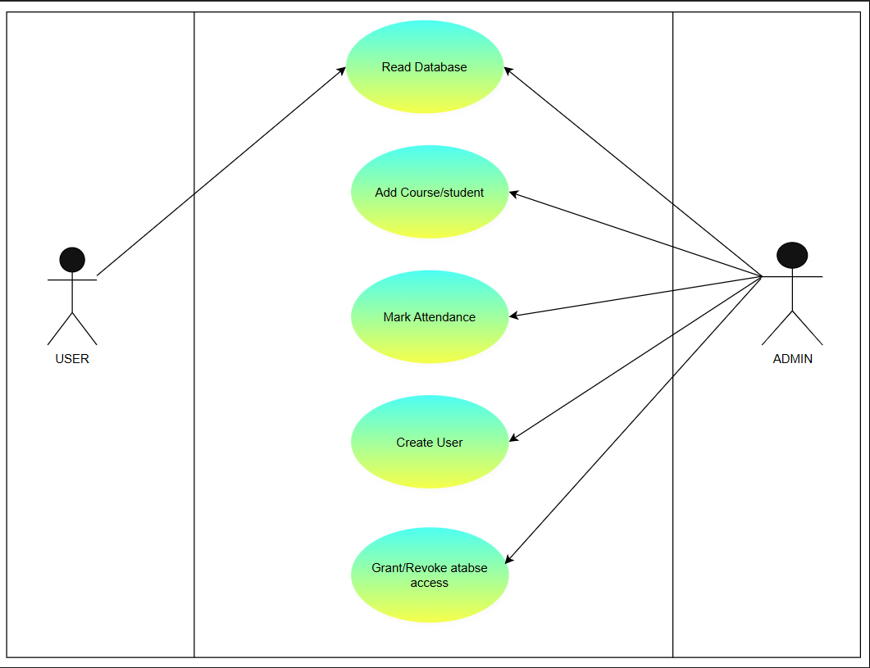

Software Requirements Specification (SRS)

The Software Requirements Specification (SRS) document describes the functional and non-functional requirements of the Secure Attendance Management System. It defines how the system should behave and outlines the constraints under which it must operate.

Functional Requirements
The system shall allow users to log in using valid credentials.
The system shall allow the admin to create, delete, and manage users.
The system shall allow attendance records to be added, updated, and deleted.
The system shall allow users to view and query attendance data.
The system shall enforce role-based access control.

Non-Functional Requirements
The system shall ensure data security through encryption and password hashing.
The system shall provide reliable performance with quick response time.
The system shall handle errors and invalid inputs gracefully.
The system shall provide a user-friendly interface for interaction.

Performance Requirements
The system should authenticate users within a short response time.
Data retrieval and query execution should be efficient.
The system should handle multiple operations without significant delay.

Software System Attributes

Reliability
The system should perform operations accurately and consistently without failure.

Security
All sensitive data such as passwords and attendance records are secured using hashing and encryption techniques.

Usability
The system provides a simple and structured command-line interface for easy interaction.

Maintainability
The system is modular in design, allowing easy updates and modifications.

Flexibility
The system can be extended to include additional features such as GUI or database integration.

Logical Database Requirements
The system stores user credentials, access permissions, and attendance records in structured files.
- User data is stored securely in credential files
- Access permissions define user-specific data visibility
- Attendance records are stored in encrypted format

Environment Characteristics

Hardware Requirements
- Standard computer system
- Minimum RAM required for execution
- Storage for maintaining data files

Software Requirements
- Python runtime environment
- Required libraries for encryption and hashing

Users
- Admin: manages users and data
- User: views and queries attendance

Sequence Diagram

A Sequence Diagram is a type of interaction diagram that shows how objects interact in a particular sequence of events. It illustrates the flow of messages between different components of a system over time.
In this system, the sequence diagram represents the interaction between the user, authentication module, and data storage during operations such as login and data access. It helps in understanding the dynamic behavior of the system and the order in which processes are executed.

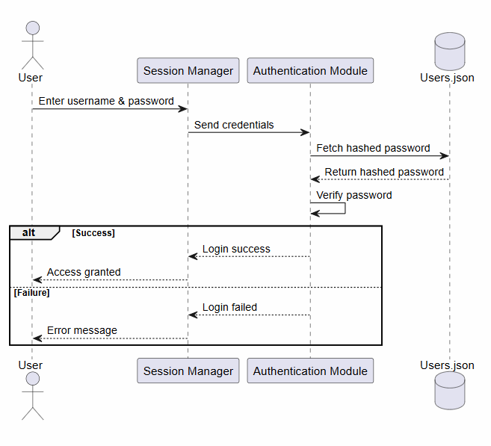

Structure chart

A structure chart is a hierarchical diagram that represents the organization of modules in a system and the relationships between them. It shows how control is passed between modules and how data flows during execution. Unlike data flow diagrams, structure charts focus on the functional decomposition of the system and the calling relationships among modules.
In this system, the main module controls the overall execution and delegates tasks to the session manager, which further interacts with authentication, data management, query, and encryption modules. Each module performs a specific function, ensuring modularity and ease of maintenance.

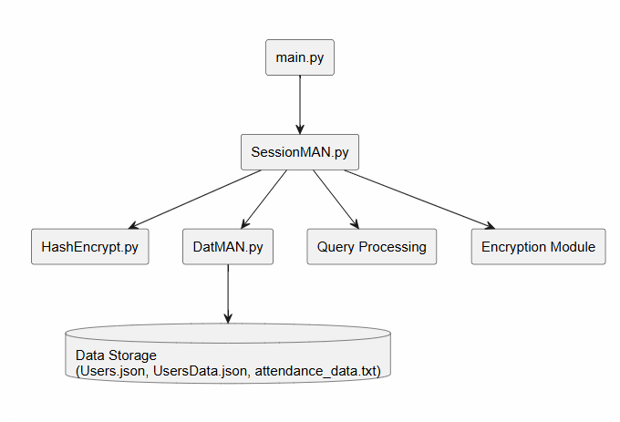

Project Management

Timeline Table

A timeline chart represents the schedule of project activities over time. It helps in planning, tracking progress, and ensuring timely completion of each phase of the project.

Phase | Duration
Requirement Analysis | 2 days
Design (DFD, UML) | 3 days
Implementation | 5 days
Testing | 2 days
Documentation | 2 days

Computing FP (Function Points)

Function Type | Count | Complexity | UFP
External Inputs | 10 | 4 | 40
External Outputs | 8 | 5 | 40
External Queries | 6 | 4 | 24
Internal Files | 3 | 10 | 30
Total UFP = 134
CAF = 0.65 + 0.01 x (14 x 3) = 1.07
FP = UFP x CAF = 134 x 1.07 = 143

Effort Estimation:
Effort estimation is the process of predicting the amount of work required to develop the system.

Effort = FP / Productivity
= 143 / 6.5 ≈ 22 person-months

Cost Estimation:
Cost = Effort × Cost per month
= 22 × 7000 = ₹1,54,000

Risk Analysis

Risk analysis is the process of identifying potential problems that may affect the successful development and operation of a software system. It involves evaluating the likelihood of these risks occurring and assessing their impact on the system.
In software projects, risks may arise from technical limitations, security vulnerabilities, project delays, or changes in requirements. Proper risk analysis helps in minimizing uncertainties and preparing mitigation strategies to ensure smooth system development and deployment.
For the Secure Attendance Management System, risks are identified based on system design, data handling, and user interaction, particularly focusing on security and data integrity.

Types of Risks:
The risks in this system can be broadly categorized as:
- Technical Risks → related to system implementation and technology
- Security Risks → related to data protection and unauthorized access
- Project Risks → related to time, cost, and resource management
- Operational Risks → related to system usage and performance

Risk Table:
Risk | Category | Probability | Impact | Description
Unauthorized Access | Security | Low | High | Risk of users accessing restricted data
Data Loss | Technical | Medium | High | Loss of attendance data due to file issues
Incorrect Data Entry | Operational | Medium | Medium | Users may input invalid data
Requirement Changes | Project | Medium | Medium | Changes may affect design and implementation
System Failure | Technical | Low | Medium | Slow response during data processing
Performance Issues | Operational | Low | Medium | Slow response during data processing
Encryption Failure | Security | Low | High | Failure in encryption/decryption process

Risk Mitigation Strategies
• Implement strong password hashing and encryption mechanisms
• Regularly validate and backup data
• Handle exceptions and errors properly in the system
• Restrict access using role-based permissions
• Test the system thoroughly before deployment

Architecture Design

The Secure Attendance Management System follows a modular layered architecture, where the system is organized into distinct components connected in a structured manner.
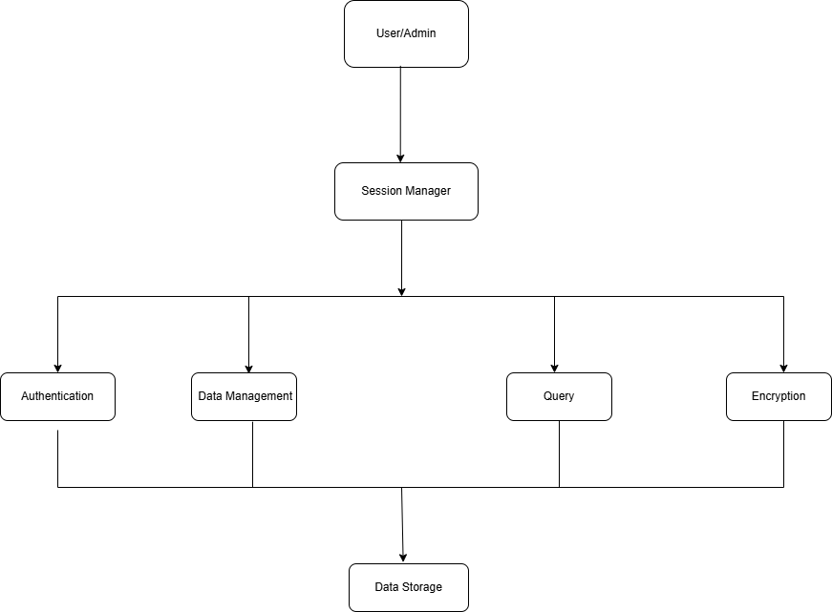

At the top level, the User/Admin interacts with the system through the Session Manager, which acts as the central control unit. The Session Manager receives user inputs and forwards requests to the appropriate modules based on the required operation.
The system is divided into core functional modules including the Authentication Module, Data Management Module, Query Processing Module, and Encryption Module. The Authentication Module validates user credentials by accessing stored data and ensuring secure login. The Data Management Module handles all operations related to attendance records such as adding, updating, and deleting data. The Query Processing Module is responsible for retrieving and filtering data based on user requests.
These modules interact with the Data Storage layer, which contains user credentials, access permissions, and attendance records. The data storage is primarily accessed by the authentication, data management, and query modules for reading and writing data.
The Encryption Module operates as an intermediate layer within the system, ensuring that all sensitive data is encrypted before storage and decrypted during retrieval. It does not directly connect to the data storage but supports other modules in maintaining data security.
This architecture ensures a clear separation of responsibilities among modules, improving maintainability, scalability, and security. The structured interaction between components allows the system to operate efficiently while maintaining data integrity and controlled access.

BIBLIOGRAPHY

1. Software Engineering: A Practitioner’s Approach
– Used for understanding software development models, DFDs, and system design concepts.
2. Software Engineering
– Referenced for requirements engineering, system architecture, and documentation practices.
3. GeeksforGeeks
– Used for concepts related to DFD, UML diagrams, and software engineering basics.
4. W3Schools
– Referenced for general programming and data handling concepts.
5. Python Documentation
– Used for implementation details and understanding Python modules.
6. Stack Overflow
– Used for resolving coding issues and debugging.

Limitations

Despite providing a secure and structured approach to attendance management, the system has certain limitations:
The system currently uses a file-based storage mechanism instead of a full-fledged database, which may limit scalability and performance when handling large volumes of data. As the number of users and attendance records increases, file operations may become slower and less efficient.
The system operates through a command-line interface, which may not be very userfriendly for non-technical users. A graphical user interface would improve usability and accessibility.
Although the system implements encryption and hashing for security, it does not include advanced authentication mechanisms such as biometric verification or multi-factor authentication, which could further enhance security.
The system relies on manual data entry for attendance, which may lead to human errors such as incorrect inputs or missing records.
Additionally, the system is designed for single-system usage and does not support realtime synchronization or cloud-based access, limiting its use in distributed environments.

Future Scope/Enhancements

The system can be further improved and extended by incorporating advanced technologies and additional features.
One of the major enhancements would be the integration of computer vision-based attendance systems, where attendance can be marked automatically using facial recognition through camera input. This would eliminate manual entry and improve accuracy.
The system can also be extended to support biometric authentication methods such as fingerprint-based attendance, providing a higher level of security and preventing proxy attendance.
Another enhancement could be the implementation of a QR code-based attendance system, where users can scan a unique QR code to mark their presence quickly and efficiently.
The system can be upgraded from file-based storage to a database-driven architecture (such as SQL or NoSQL databases), improving scalability, performance, and data management capabilities.
A web-based or mobile application interface can be developed to enhance usability and allow access from multiple devices.
Further improvements may include cloud integration, enabling real-time data synchronization, remote access, and backup facilities.

